Oxygen Valve HardwareSpecification
PB 540

Table of Contents
1. INTRODUCTION 3
1.1 Purpose 3
1.2 Scope 3
1.3 Revision History 3
2. Operation 3
3. Design Requirements 3
3.1 Technology 3
3.2 Operating pressure 3
3.3 Supply voltage 3
3.4 Gas Mix 3
3.5 Max Power (peak) 3
3.6 Steady State Power 3
3.7 Maximum Pressure 4
3.8 Ambient Temperature 4
3.9 Gas Temperature 4
3.10 Working position 4
3.11 Size 4
3.12 Mounting 4
3.13 Weight 4
3.14 Electrical connection 4
3.15 Pneumatic connection 5
3.16 Pneumatic joint type 5
3.17 Gas pathway labeling 5
3.18 RoHS compliance 5
3.19 Life 5
3.20 Labelling 5
3.21 Packaging 6

INTRODUCTION

Purpose
The purpose of this document is to provide the requirements for the Oxygen shut off valve for PB560, PB540 and PB520

Scope
This specification describes the physical, functional and electrical requirements for the Oxygen shut off valve.

Revision History
Revision | Date | Author | Change Description
A | 02 Jun 08 | J.C. Cabrera | Initial Release of Specification.
B | 03-Nov-2008 | G.Sanchez | Minor formatting changes, clarified Requirements, modified power requirements to reflect product requirements.

Operation
This valve is used to shut off the Oxygen source after a ventilation stop on the ventilators for continuous or temporary use.
This device provides a safety and security function by preventing oxygen from flowing into the device when ventilation is stopped (Standard UL60601).

Design Requirements

Technology
HWSOV1 The Oxygen shut off valve shall consist of a 2 way solenoid.
HWSOV2 The solenoid shall be normally closed with a maximum leak at 6bar ≤1x10⁻³ ⁽mbar x L/sec) at 0V.

Operating pressure
HWSOV3 The oxygen shut off valve shall operate at 6bar.

Supply voltage
HWSOV4 The oxygen shut off valve shall operate with a voltage source of 24VDC ± 15%

Gas Mix
HWSOV5 The oxygen shut off valve shall operate within specification with an oxygen gas source up to 100% oxygen.

Max Power (peak)
HWSOV6 The oxygen shut off valve shall have a peak power consumption less than 6W.
This requirement will be applicable for pulses exceeding 5ms.

Steady State Power
HWSOV7 The oxygen shut off valve shall have a steady state power consumption less than 0.75W.

Maximum Pressure
HWSOV8 The oxygen shut off valve shall operate with a pressure source less than 10bar .

Ambient Temperature
HWSOV9 The oxygen shut off valve shall operate within specification when ambient temperature is within 0 to 50°C.

Gas Temperature
HWSOV10 The oxygen shut off valve shall operate within specification when gas temperature is within 0 to 40°C.

Working position
HWSOV11 The oxygen shut off valve shall operate in all 6 axes.

Size
HWSOV12 The oxygen shut off valve shall have the following dimensions: Length 45.2mm ± 0.5, Height 20.7mm ± 0.5, Width (including fitting) 44.6mm ± 1
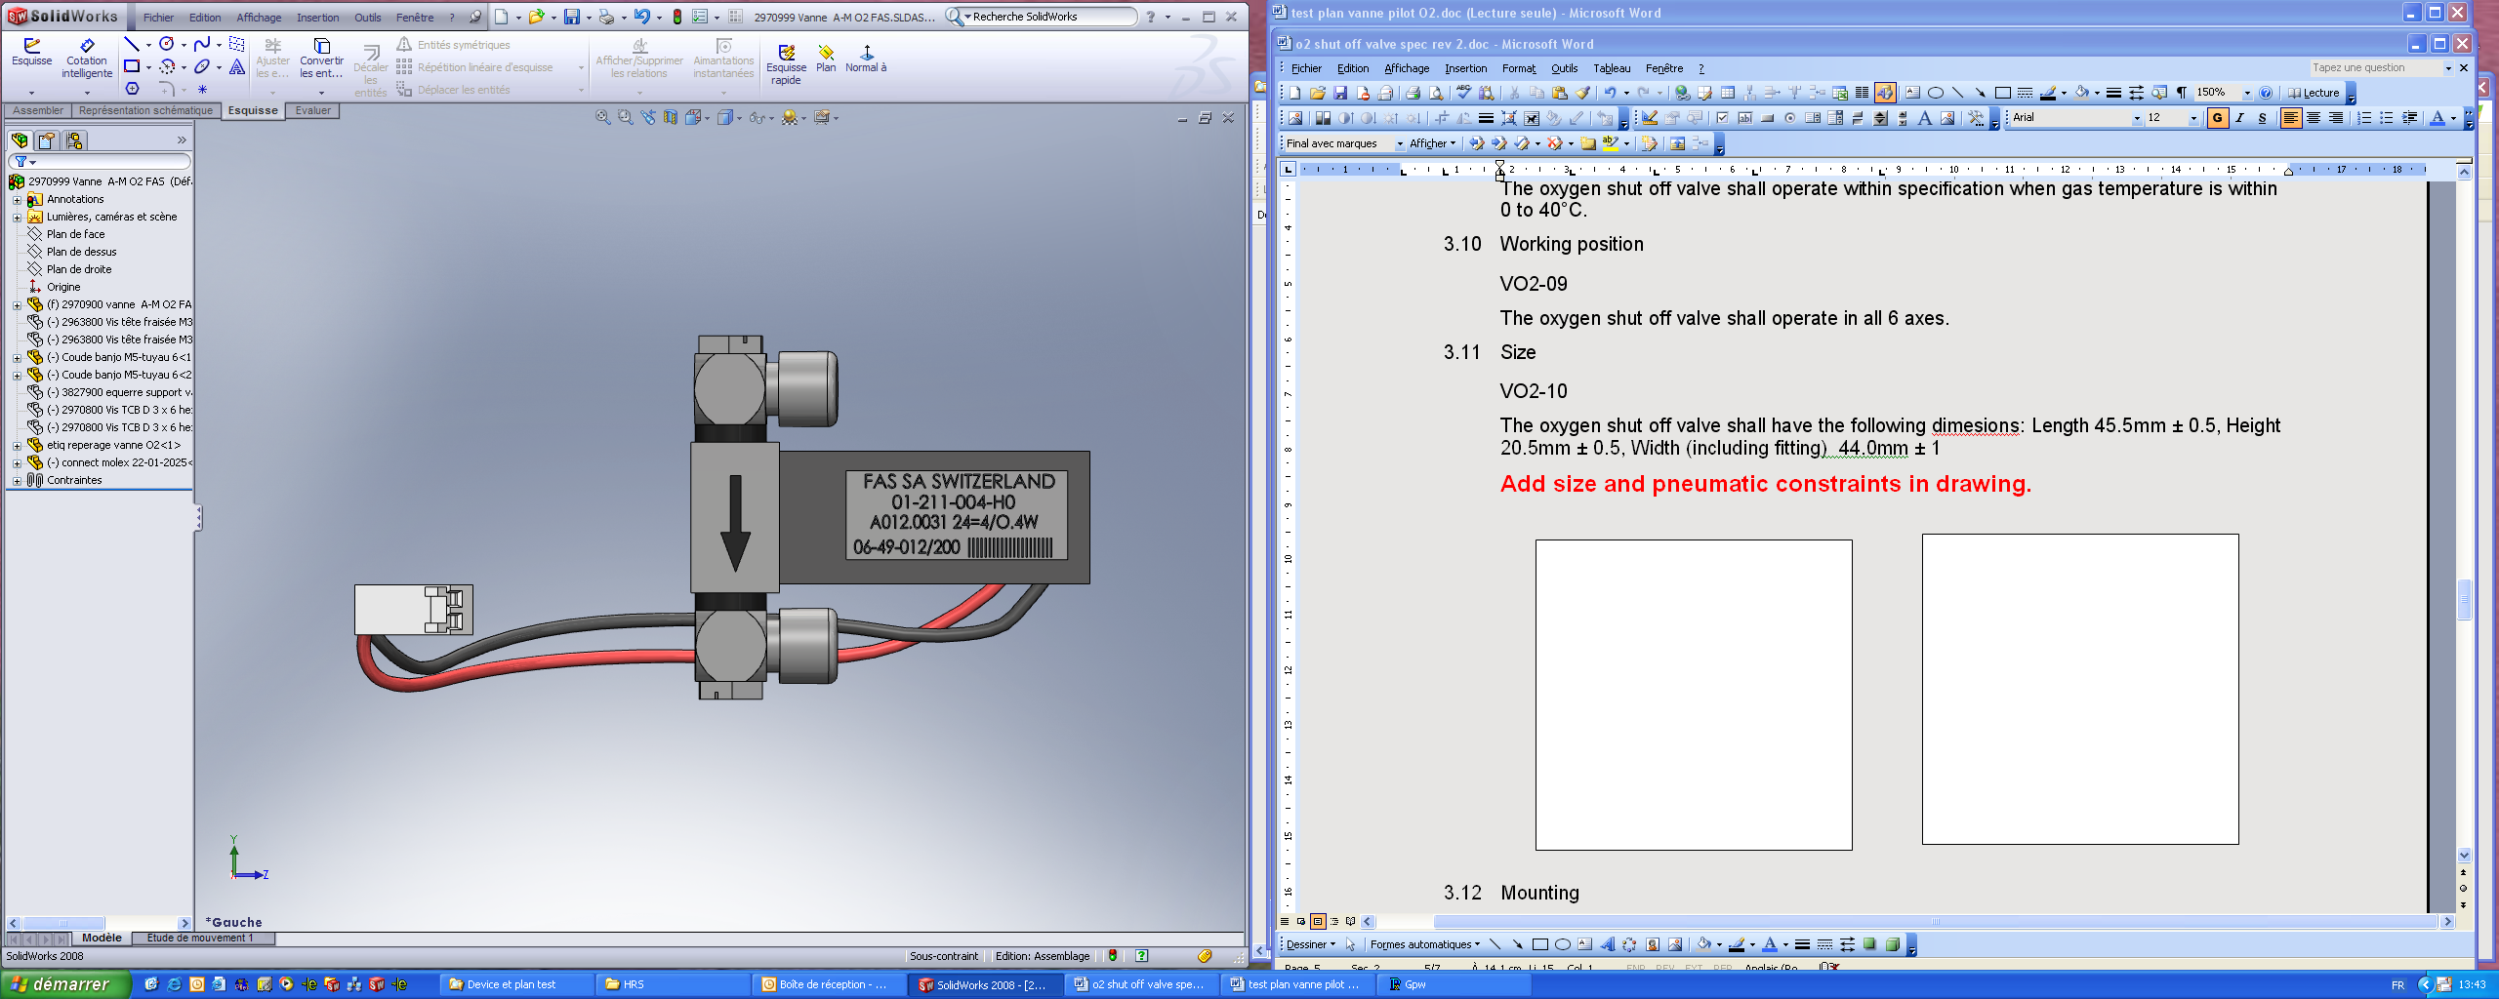
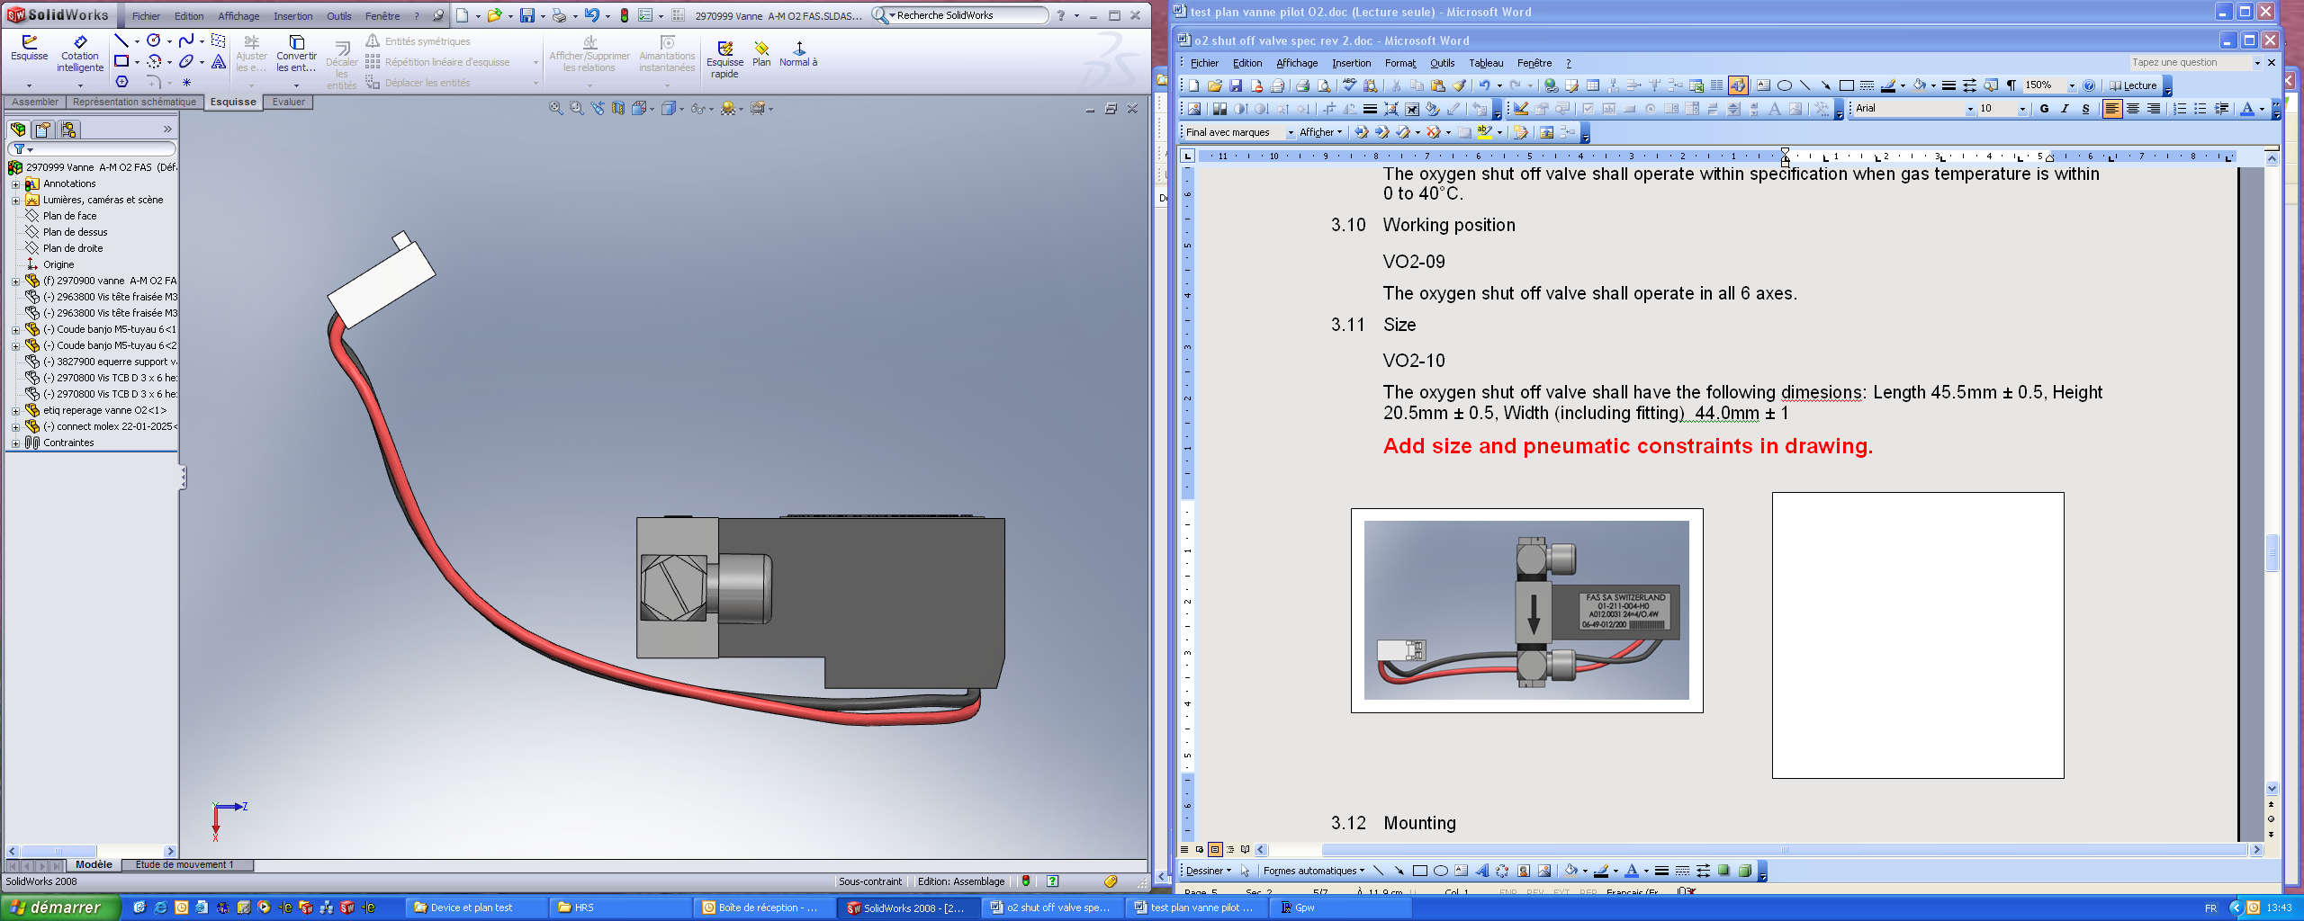
44.6
45.2
20.7

Mounting
HWSOV13 The oxygen shut off valve shall be mounted with 2 screws PT K30 Length 6mm.

Weight
HWSOV14 The oxygen shut off valve shall have a weight of less than 52g.

Electrical connection
HWSOV15 The oxygen shut off valve shall have been terminated with a Molex type 22-01-2025 / contacts 08-50-0031.
HWSOV25 The Black and red wires shall be AWG 24 UL-1569 and within Length(L) = 180mm±5.

PIN NUMBER | SIGNAL NAME |  | PIN NUMBER | SIGNAL NAME
1 | Red wire (+) |  | 2 | Black wire (-)

Pneumatic connection
HWSOV16 The oxygen shut off valve shall have gas inlet and outlet ports type SMC M-5HLH-6 with a diameter of 4mm and the valve and the tubing shall withstand a pressure of 10bar. The tubing is added as a secondary operation and is not part of the valve.

Pneumatic joint type
HWSOV17 Input fitting shall be mounted on the face #3 and oriented to the face #5
HWSOV18 Output fitting shall be mounted on the face #4 and oriented to the face #5
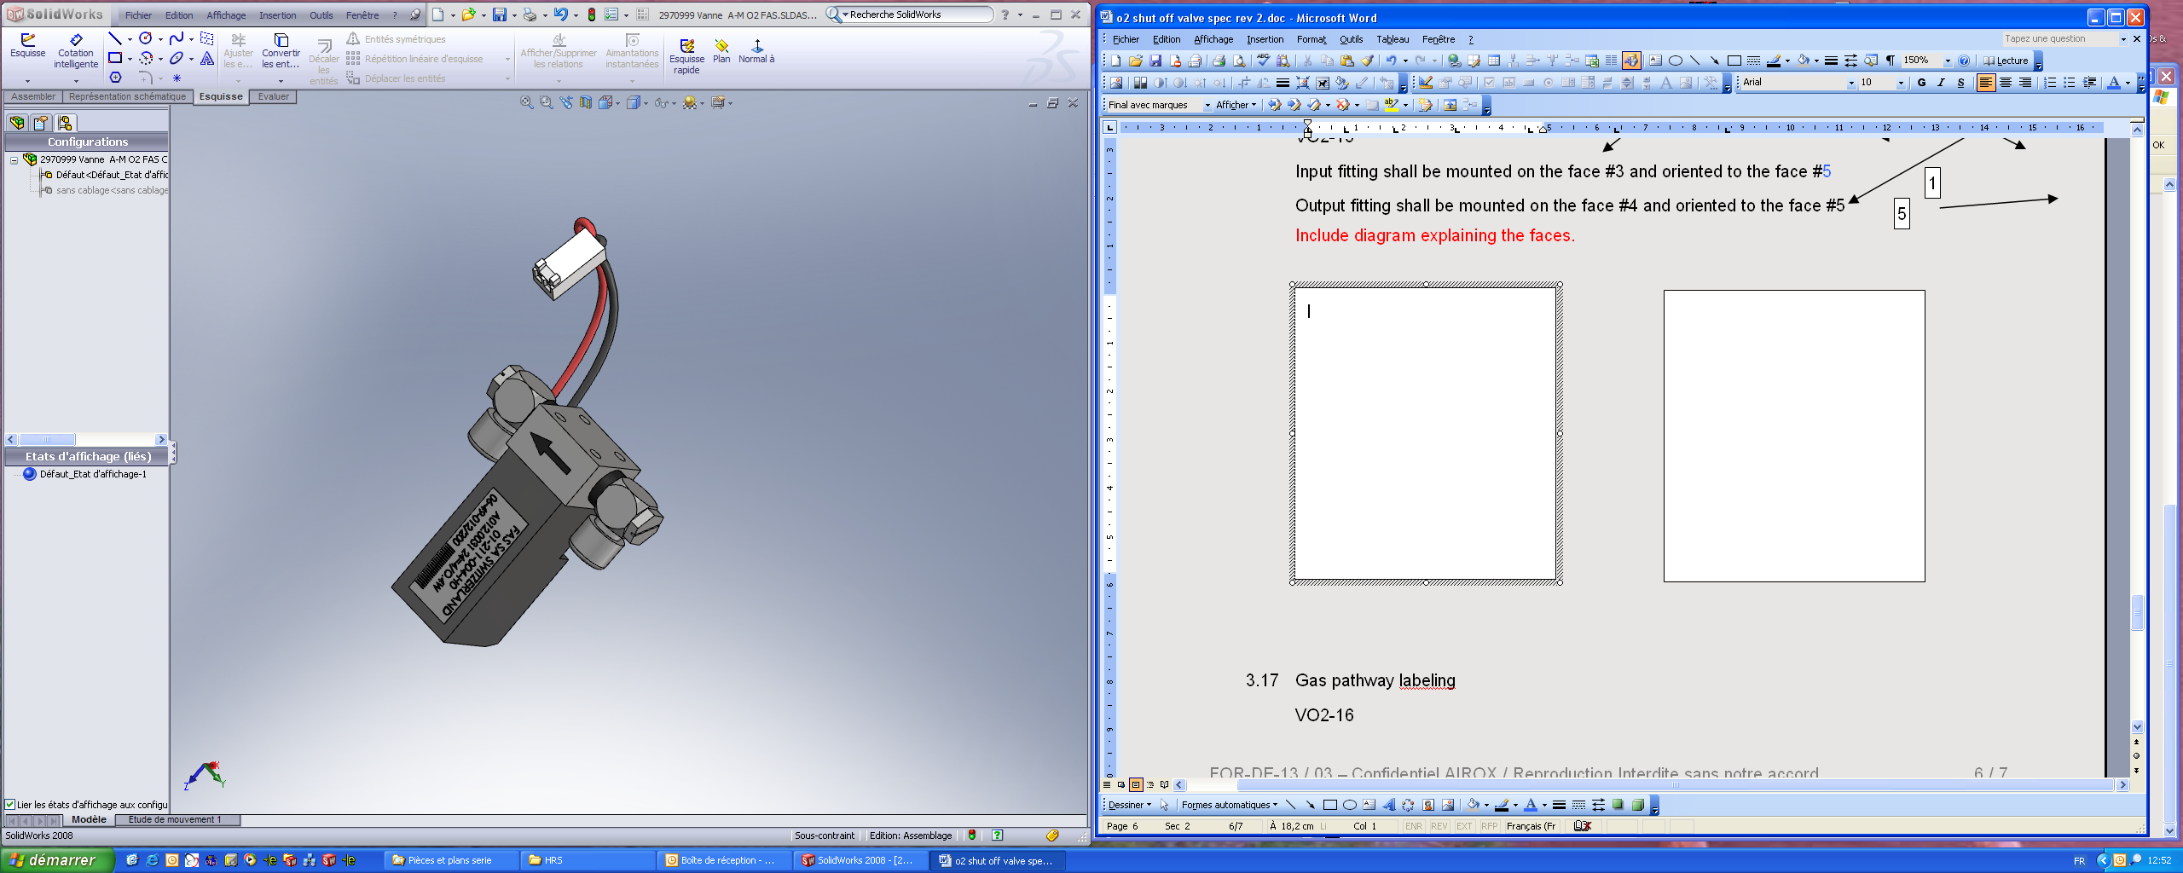
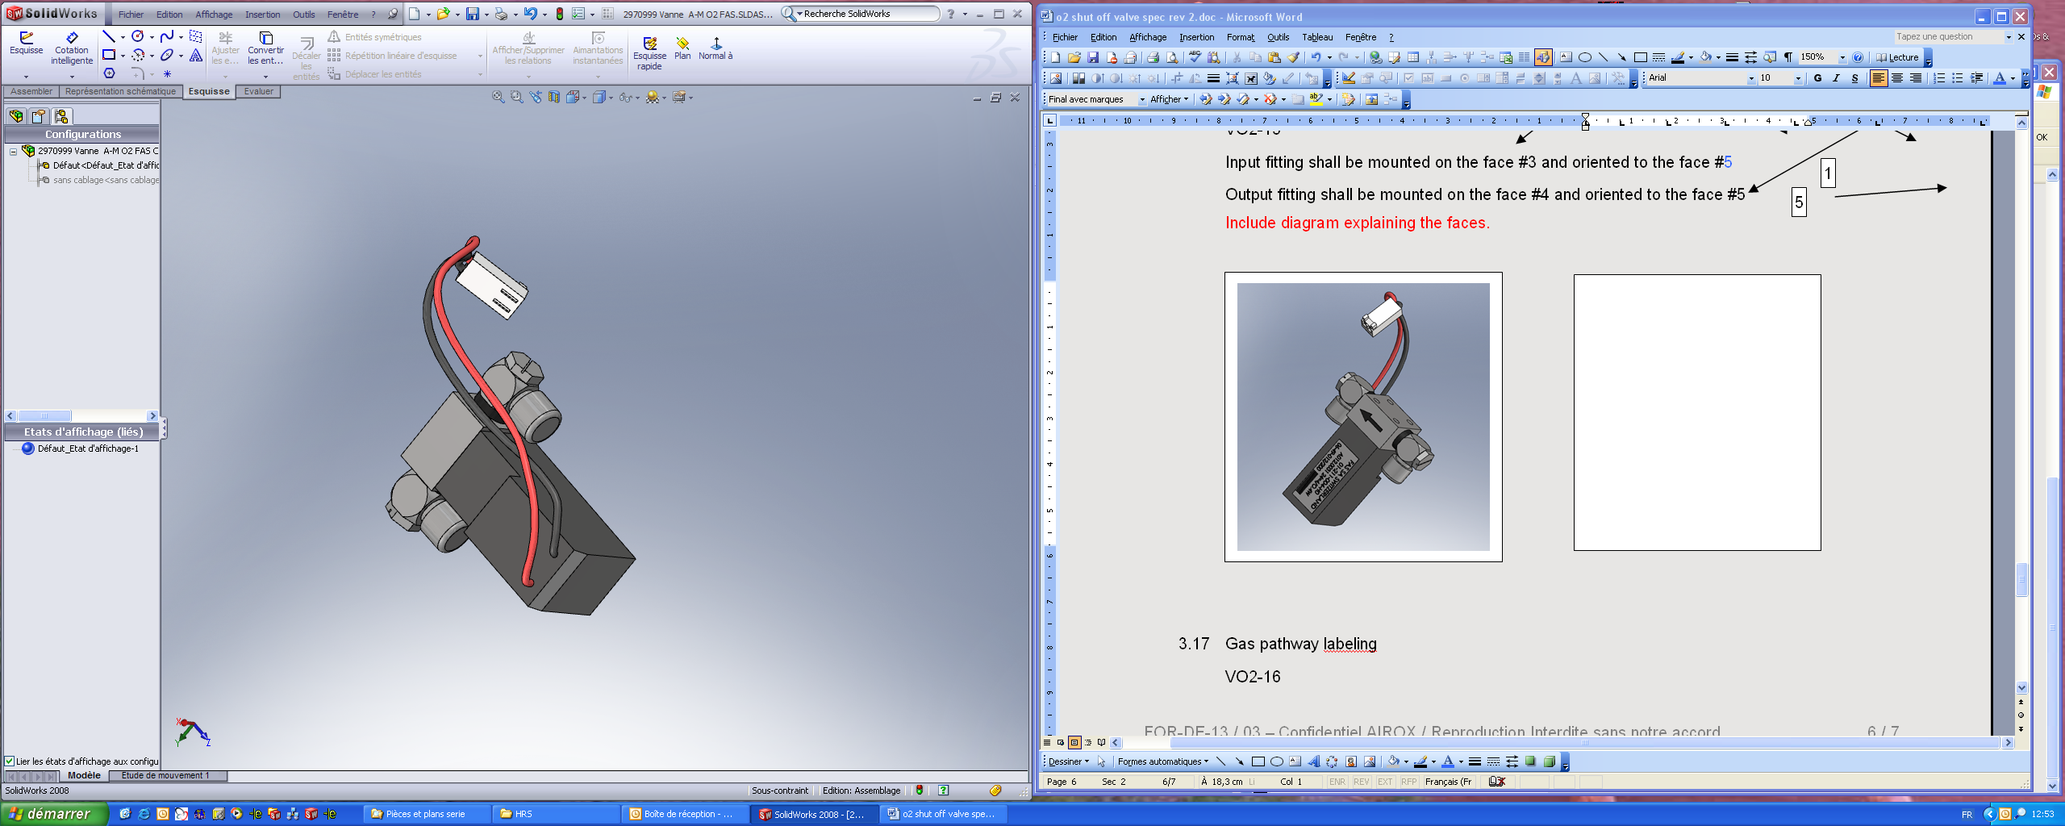
4
2
6
3
1
5

Gas pathway labeling
HWSOV19 The oxygen shut off valve shall have labelling indicating gas direction, on face #2.

RoHS compliance
HWSOV20 The oxygen shut off valve shall be RoHS compliant per standard 2002/95/CE.

Life
HWSOV21 The oxygen shut off valve shall have a life ≥ 1,000,000 cycles.

Labelling
HWSOV22 The oxygen shut off valve shall be labelled with the manufacturer name (nnnnnnnnnnnnnnnnnnnn), agile part number (XXXXXXX) with the current revision (RR) and serial number with year (YY) / week (WW) and part number (ZZZ) / lot quantity (QQQ).
nnnnnnnnnnnnnnnnnnnn XXXXXXX – Rev RR
YY - XX - ZZZ / QQQ

Packaging
HWSOV23 Packaging shall be tested to the international standard ISTA2A.
HWSOV26 Packaging shall be designed to minimize the level of waste and waste disposal as per the European Directive on handling waste packaging.
Certificate Of Compliance is required.

